Assignment 16.1

Given a list of numbers = List[int] {1,2,3,4,5,6,7,8,9,10}

- Find the sum of all numbers:

Creating a list
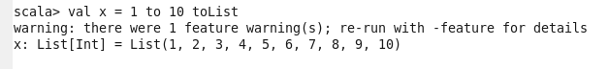

Sum of all numbers
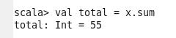

- Find the total elements in the list

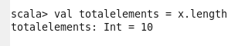

- Calculate the average of the numbers in the list

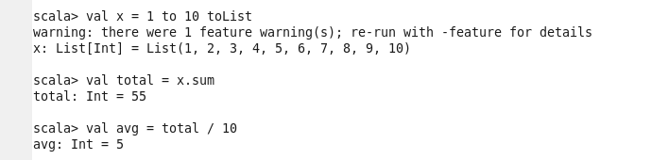

- Find the sum of all the even numbers in the list

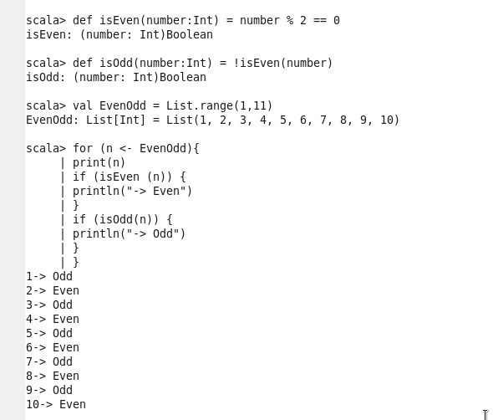

- Find the total number of elements in the list divisible by both 5 and 3

